**PXL-Digital**

Bachelor in de elektronica-ICT

**Writing: Ledcontroller**

Vak: POW

Docent: Eric Caers

Pieter Brouns

1. Content

I. Content 1

II. Product Description 2

III. How to Build 3

IV. Encountered difficulties 5

V. Bill of Materials 5

VI. Bibliography 5

1. Product Description

The project will make it possible to control three ledstrips with an android app through a Wi-Fi signal. There will be a possibility to choose which ledstrip will light up and in which color in the RGB spectrum. This controller is made for ledstrips that work with 12 volt. And the controller itself needs a supply between 5 and 12 volts. The name of the app is WiFi control from Elektor Team. A phone will be able to connect to a Wi-Fi signal emitted by the ESP8266 chip on the PCB. When the IP-adress of the ESP module is written in the app, it will be able to control the ATmega-chip, which will control the outputs.

1. How to Build
2. Step 1: Draw the schematic in Altium

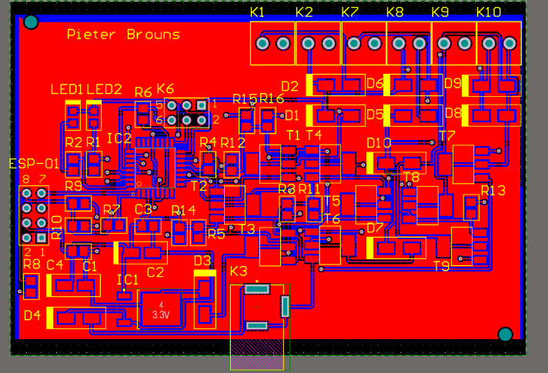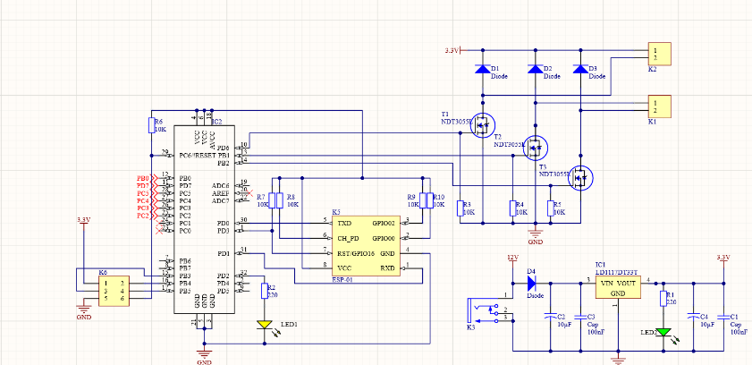The schematic is displayed the elektor magazine. To make the PCB, the schematic will have to be drawn in Altium and eventual changes can be added. After the schematic is done, it can be converted into a PCB design. All the components’ footprints will have to get put into the PCB design and after that, all the connections will have to be made. The polygons will have to be present as well, because otherwise, the PCB can’t get produced. Put some holes into the PCB for a better connection to the case and last but not least, put your name on it to take the credit.

Figure :schematic

Figure : PCB design

1. Step 2: Buying components

Make a BOM (Build Of Materials) out of the schematic in Altium, these are all the components that are needed. Almost all components can be found on mouser for a pretty cheap price. The dimensions of each component can be viewed in a datasheet mentioned on the components page on mouser. Make sure all the ordered components can be placed on the footprints that are selected in Altium, otherwise they won’t be able to fit onto the PCB. If this is not the case you can always change the footprints in Altium too.

1. Step 3: Soldering the components onto the PCB

When the PCB and the components finally arrive, the components can be soldered onto the PCB. Make sure to solder the polarised components facing the right way and to not overheat the SMD components, especially the leds. The ESP-01 will not have to be soldered onto the PCB since it can’t handle the heat, instead it will be placed onto a header. There will be no pictures of this since the PCB has not arrived at this point.

1. Step 4: Making the case

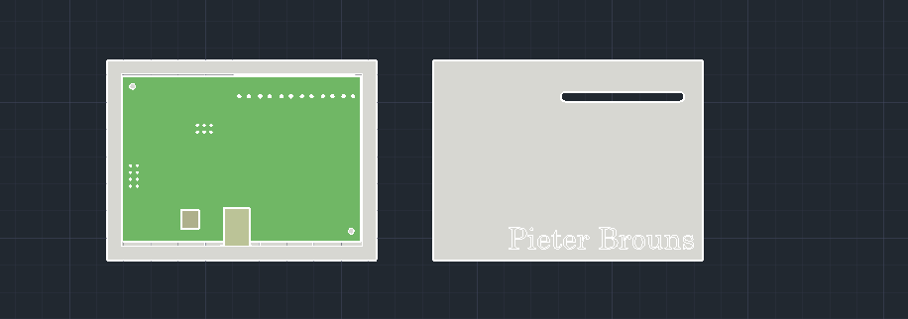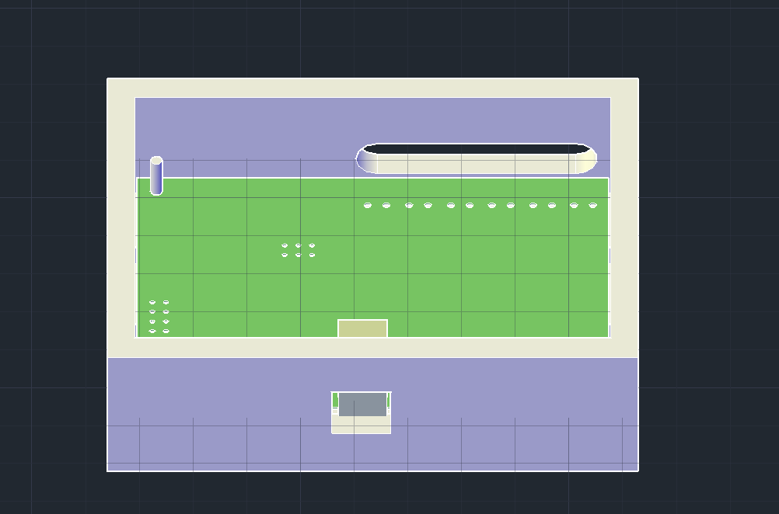The case can be 3D-printed with a 3D drawing made in AutoCAD. Measure the correct dimensions of the PCB and put holes in the case for every in-and output. Put some screw holes into the case as well so you can screw the PCB onto the case. And at last make a lid to close the case. Putting your name on it is also always a nice touch.

Figure : case

Figure : case and lid

1. Step 5: The setup

Last but not least, screw the ledstrips into the PCB-ports and plug the controller into the transformer that will turn the 325 volts AC from the wall into 12 volts DC for the ledstrips. Connect the project to your phone through the app and the project is finished.

1. Encountered difficulties

There were not a lot of encountered difficulties since everything was always very clear what to do. The biggest encountered problem was probably the ordering of a wrong component, it was a header that was just a lot smaller than it had to be so it would not fit onto the PCB. Luckily one of my junior-colleagues had some reserves of the exact header I needed so I could get one from him. Another difficulty was the fact that there were 500 errors in the Altium design at one point, this was solved by changing some clearance rules after a long search. The last difficulty was the fact that the AtMega-chip had to be pre-programmed from elektor, so it had to come from the website from elektor. Because of this, it costed 17,9 euros.

1. Bill of Materials

This bill of materials includes all the components used for the project and its price, except the case since it has not been printed yet so there is no way to know the price. The shipping costs are included in all the prices. All the components except the ATmega were ordered from mouser, the ATmega was ordered from elektor and the PCB was ordered from JLCPCB. The orders from mouser arrived the 20th of march, the ATmega arrived 2 days later and the PCB is on it’s way on the moment of writing this.

|  |  |  |
| --- | --- | --- |
| **Components** | **Amount** | **Price** |
| PCB | 5 | € 30,79 |
| ESP-01 | 1 | € 4,02 |
| ATmega328P-AU | 1 | € 17,90 |
| Ceramic capacitor | 2 | € 1,12 |
| Elektrolytic capacitor | 2 | € 0,32 |
| LD1117D Voltage Regulator | 1 | € 0,41 |
| NDT3055L MOSFET | 9 | € 5,91 |
| S1A Rectifier | 10 | € 1,29 |
| DC Power Connector | 1 | € 1,78 |
| 4x2 header | 1 | € 1,20 |
| Fixed Terminal Block | 6 | € 4,50 |
| 2x3 header | 1 | € 0,25 |
| Green smd LED | 1 | € 0,16 |
| Yellow smd LED | 1 | € 0,16 |
| 9x1 header | 1 | € 1,33 |
|  |  | € 71,14 |

1. Bibliography

Aarts, R., & Valens, C. (2016). De terugkeer van de Wi-Fi-besturingskaart. In elektor, *elektormagazine* (p. 132). Limbricht: Elektor International Media B.V. Opgehaald van Elektor.

*Mouser*. (sd). Opgehaald van Mouser.com